**LAB 1**

**OBJECTIVE**

To be familiar with banking office model and its working system environment using AnyLogic simulation software.

**THEORY**

Simulation is an experiment in a computer where the real system is replaced by the execution of the program that mimics (imitate) the behavior of the real system. It involves the generation of the artificial history of a system and observing that history to draw inferences concerning the operating characteristics of the real system.

Model is a simplification of the reality.

Bank office model is also a type of simulation which shows us how a queuing system works. Queue is generally the line where the entities or customers wait and the combination of all entities in system being served and being waiting for services will be called as queuing system.

**ACTIVITIES**

The activities that we performed to observe the queuing system of banking model using AnyLogic simulation software are shown below with all steps involved to perform the task.

**Phase 1. Creating a Simple Model**

First, we create a new model by clicking new on toolbar button where New model dialog box is displayed.

We specify model name here. After including model name, we click finish to complete the process.

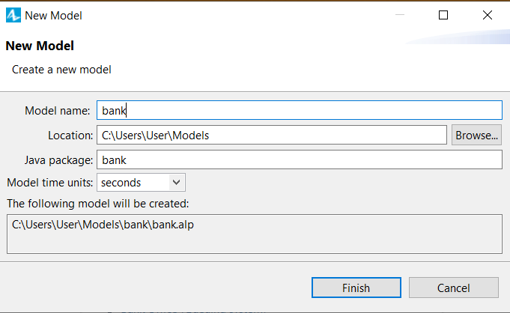

We are than given a workspace with graphical editor where we also get main where we perform all our work.

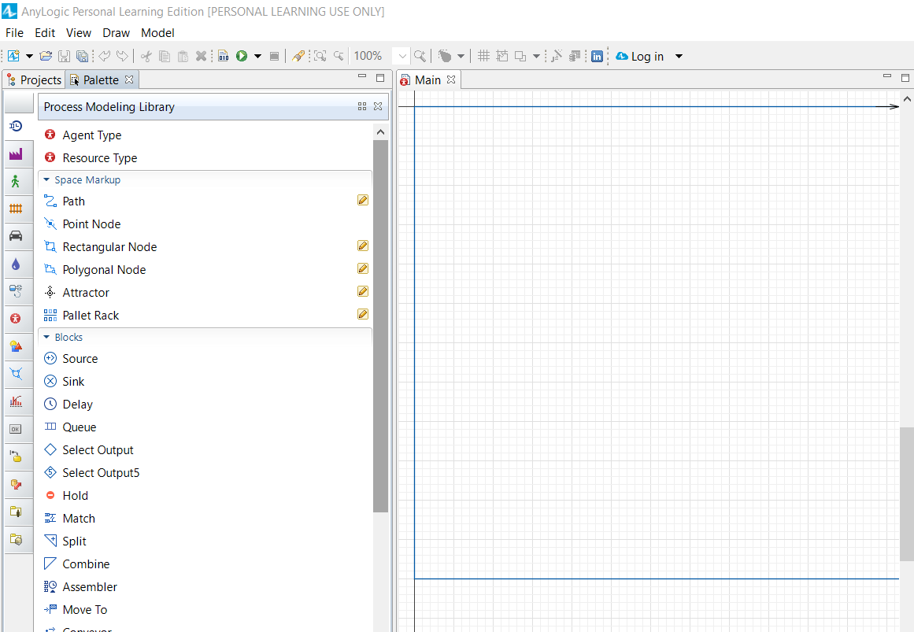

**Creating the flowchart defining the process**

**Create the model flowchart**

After creating model, AnyLogic will switch to the Palette view and display the process modeling library palette:

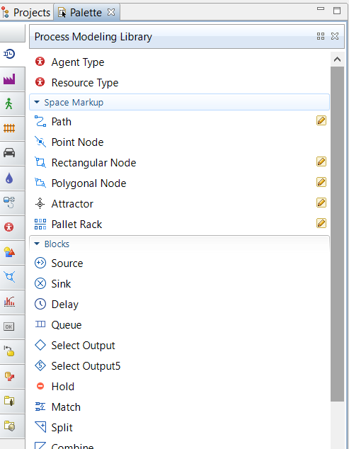

Add**Process Modeling Library** blocks on the diagram and connect them as shown in the figure below. To add a flowchart block on the diagram, drag the required element from the palette into the graphical editor.

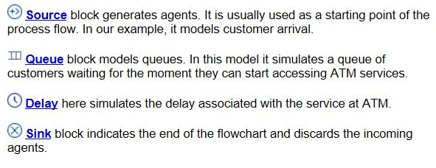

**Configure the flowchart blocks**

1. To modify the properties of some model element, first select it by clicking on it in the graphical editor or in the **Projects** view. This opens the properties of this element in the **Properties** view.
2. Select *source* block. In the **Properties** view, specify how often customers arrive. Type 0.3 and select *per minute* for **Arrival rate**.

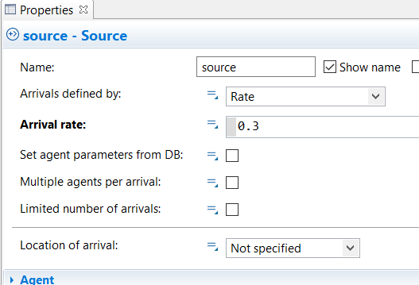

1. Modify the properties of the *queue*. Set queue capacity to 15 agents. At most 15 customers will wait in a queue.

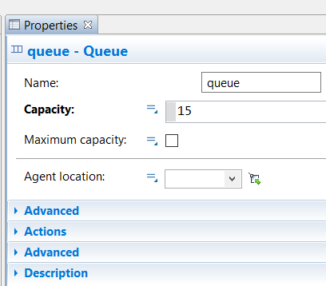

1. Modify the properties of the *delay*. Name the block *ATM*. Specify the processing time. Assume that processing time is triangularly distributed with a mean value of *1.5*, min of *0.8* and max value of *3.5* *minutes*.

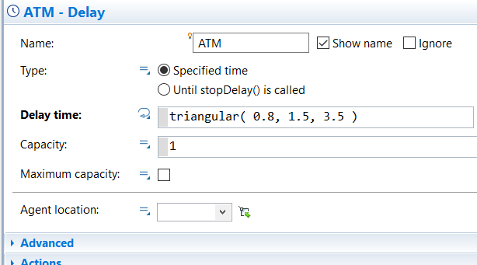

**Running the model**

After finishing modeling of queuing system, we are ready to run the resulting model. The running of the simulation involves steps which are shown and described below:

**Start the model**

Click the run toolbar button and choose the experiment to run from drop down list.

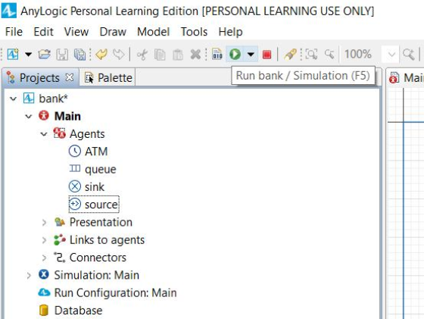

Separate interface is opened and we need to click the run button and we get output.

**OUTPUT**

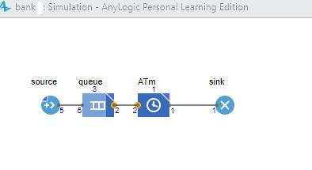

**CONCLUSION**

Hence, we implemented bank office model for queuing system using any logic simulation software and learned the process involved in queuing system.